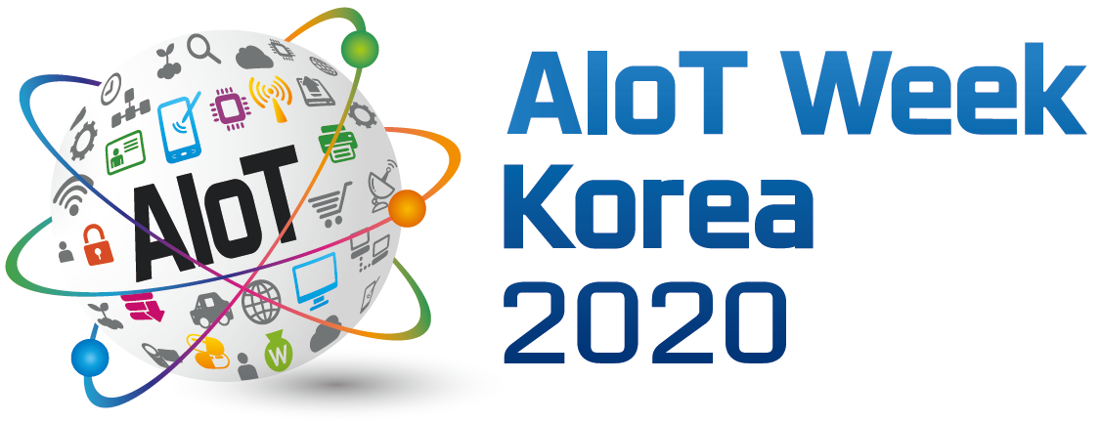 |  | AIoT International Conference Presentation Speaker Application Form

※ Please send us an E-mail(jhw@kiot.or.kr) until 6/28 (Fri)
Presentation Indicate ☑ on interested topic
▶ Current Status and Future Prospects of AIoT Convergence in Major Industries □
□ Smart city |  | □ Smart mobility | □ Smart farm |  |  | □ Healthcare |  | □ Construction |  |  | □ Logistics | □ etc.  ( )
□ Smart factory |  | □ Smart home | □ Autonomous driving |  |  | □ AR/VR |  | □ Finance |  |  | □ Marine
▶ Trend of AIoT Technology Development in Korea and abroad and Future Direction. □
▶ COVID-19 Pandemics, Impact on ICT Industry. □
▶ AIoT New Technologies, Standards, Security Trends and Issues □
Speaker | Company |  |  |  |  |  |  |  | Name(Title)
 | Department |  |  |  |  |  |  |  | Contact No.
 | e-Mail |  |  |  |  |  |  |  | Nationality
 | Career |  |  |  | o  o  o
Subject
Summary
Of
presentation
Contact  representative | Company |  |  |  |  |  | Department
 | Name(Title) |  |  |  |  |  | Contact No.
 | E-mail
※ Fill up contact (representative), when representative of the speaker will fill up the application form.

